REQUEST FOR QUOTATIONs (RFQ)

Date: November 15 ,2022 Ref No.: FY23-RFQ-0089

Supplier/Service Provider: ____________________________________________

RFQ launch date: | November 15, 2022
Deadline for quotation submission: | November 27 ,2022
Quotation submitted to: | Tel: +249 (0) 183 231 905 / 6  Mobile: +249(0)900905225  Email: co.sudan@plan-international.org
Purchase Requisition Number

Plan international Sudan invites you to submit a quote in accordance with the requirement of the request for quotation. Quotes must be received by Country Office- Building 26, Block # 12, Street 27. Box: 528, East Khartoum, Sudan in no less than the date stated above for the following items:

# | Description | QTY | UOM | Unit price | Total price | Delivery Date (calendar days)
1 | Supply materials and installation of Sustainable Solar Systems ( Container) as per attached documents with RFQ ( Scope of works, drawing, Sustain Compact Data Sheet, Packing list)

Requirements

Documents | - [Renewed Business License, VAT or Tax Registration if any, company profile, previous similar works certificate, CVs of technical & expertise staff
Specification and Scope of Requirement | - As per attached summary table for Scope of Work
Quotations | - If the items on this request are not in stock, please indicate on this form when the items would be available.  - Indicate on the quotation if the prices provided are inclusive of tax.
Delivery Terms and Costs | - Please indicate the delivery terms to be used and any associated costs.
Delivery location | - White Nile State – Kosti Craft Center
Payment Terms | - Please indicate if payment will have to be made upon delivery/ on Credit/ in Advance/ other

Evaluation of Quotes
Bids will be assessed against predetermined criteria which has been developed and agreed by the evaluator Panel prior to launching this RFQ process. The information gathered in Scope of work table, and any other requested documentation as in the above requirement table , will be used to evaluate and score each Bid against this set criteria. Please find further details in the below table:
 | Criteria | Bidders must demonstrate…… | Weight
Compliance | RFQ Compliance and Completion | - Satisfactory completion of all documentation requested with sufficient information, submitted no later than the Closing Date specified.  - Agreement to our mandatory policies as set out in ‘ Non-Staff Code of Conduct.’ Supplier Questionnaire | Pass/Fail. Bidders who do not meet these minimum requirements will not have their Bids further assessed.
Technical Proposal  (65%) | Lead time | - Lead times offered meet requirements of Project implementation | 10%
 | Ability to meet Specifications | - Able to provide all goods/materials at the required specifications and minimum alternatives offered  - Meets the required credentials to perform the supply of materials | 15%
 | Quality | - Provides copy of Quality Assurance certificates (e.g. ISO9001) | 15%
 | Experience | - Meets the required credentials to perform the service - expertise/skills, demonstrated relevant capabilities and experience to manage this project | 15%
 | References | Previous experience in similar Projects, Previous experience working with INGOs, etc. | 10%
Gender Responsive (5%) | Gender Sensitive Practices and Policies | As part of our ongoing Gender Responsive  Procurement Initiatives, Bidders will be  allocated 5% of the overall score if they meet  one or more of the following:  - If headed up by a woman  - If supplier is a women-owned business: A legal entity in any field that is more than 51% owned, managed, and controlled by one or more women.  - If the % of women in management positions is over 35%  - If % of women workers is 55% or above  - If robust gender equality initiatives are in place and active. E.g. WEPs signed, gender equality procurement policy, any additional gender-sensitive program implemented. | 5%
Financial Proposal  (30%) | Pricing Schedule | - Completion of ‘Scope of works – Pricing Schedule’ with all requested information  - Fixed pricing  - Economically advantageous for the organisation  - Bank statement | 30%

Plan International, at its sole discretion, will select the successful Bidder.

Plan international shall be free to:
- Accept the whole, or part only, of any submission
- Accept none of the proposals
- Republish this Request for Quotations

Plan International reserves the right to keep confidential the circumstances that have been considered for the selection of the.

Women-owned businesses and companies actively engaged or advancing gender equality and women empowerment in the workplace are especially encouraged to apply.

Value for money is very important to Plan International, as every additional £ saved is money that we can use on our humanitarian and development work throughout the world.

Plan International may award multiple contracts and all contracts will be non-exclusive.

Payment Terms

Please note that, if successful, Plan International’s standard terms of payment are 10 days after the end of the month of receipt of invoice, or after delivery of the order, if later.

Plan International’s Principles
The supplier must ensure compliance to Plan International’s Non-Staff Code of Conduct.

Clarifications
Invited companies must ensure that their offer is complete and meets Plan International’s requirements. Failure to comply may lead to the offer being rejected. Please therefore ensure that you read this document carefully and answer fully all questions asked.

If you have any queries in relation to your submission, or to any requirements of this tender, please contact us on the address provided on the first page of this RFQ document.

Thank you for your quotation.

Plan International Representative |  |  | Supplier Representative
Name | Ahmed Mohamed |  | Name
Title | Supply Chain Lead |  | Title
Signature | 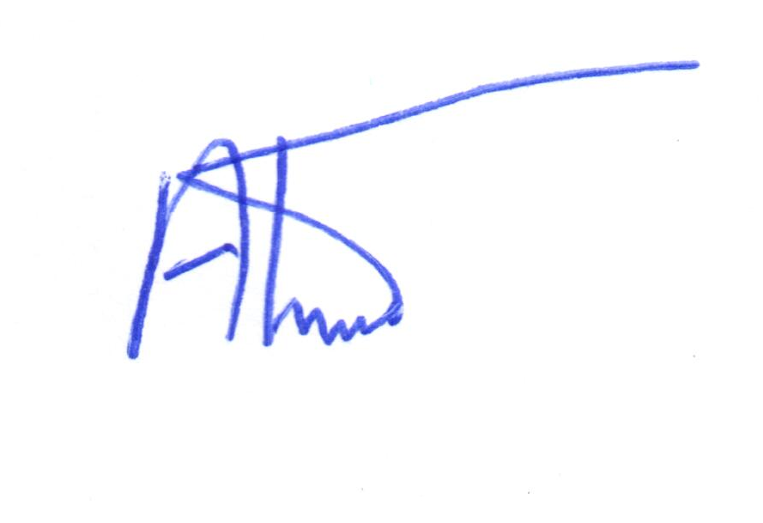 |  | Signature
Date | November 15,2022 |  | Date

